Keep Moving, Keep Doing, Keep Living
ON WITH THE BUTTER!
Spread More Living onto Everyday Life
by Heidi Herman

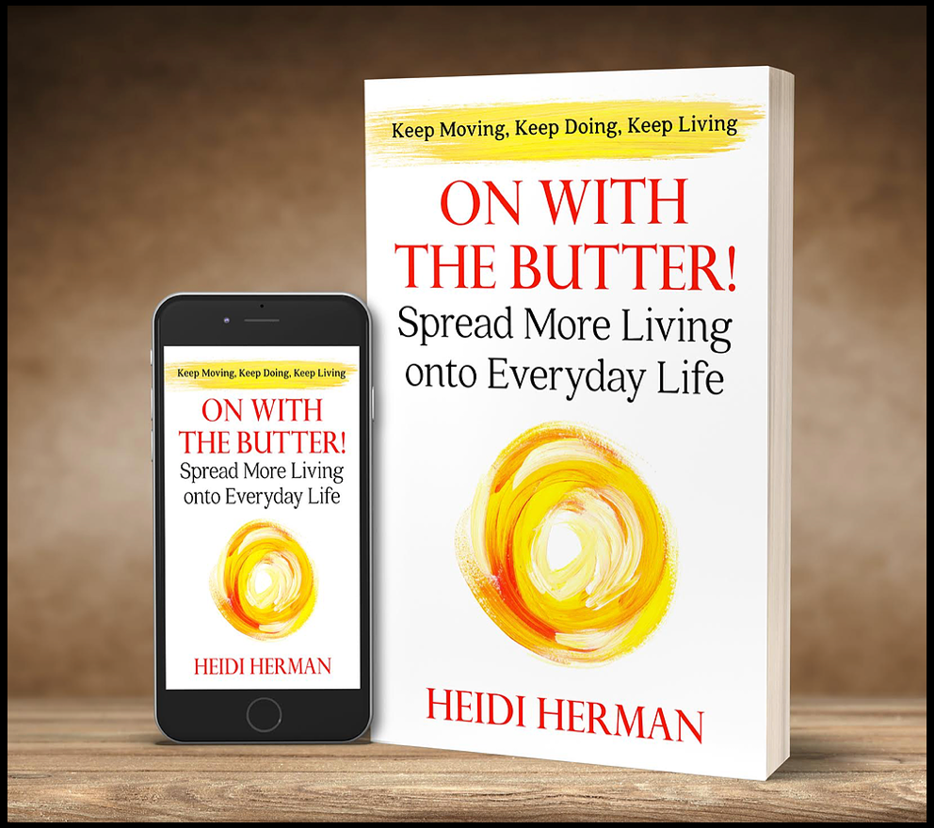

July 1, 2020 (Sioux Falls, SD) – Hekla Publishing will be releasing a new retirement & aging book - On with the Butter! Spread More Living onto Everyday Life by Heidi Herman in August 2020.

This new book is filled with encouragement and ideas to add more vitality and activity into your everyday life.

Genre: Non-Fiction / Retirement / Aging / Self-Help / Motivational

“This book was inspired by my mother, who lived every day of her life to the fullest,” says Heidi Herman. “After my mom's recovery from a stroke in 2016 at the age of 92, my mom began promoting the message of living life with vitality no matter what your age. I helped her achieve and log 93 new activities between her 93rd and 94th birthdays, just to show you're never too old to have fun. ‘On with the Butter’ is one of the countless things I learned from my vivacious Icelandic mother. “Just keep moving” was her favorite mantra. She taught me by example to embrace life and live in the moment.” I thought of Mom as a life adventurer. She taught me to embrace life with exuberance. Well into her nineties, she inspired those around her simply by the way she lived. She was constantly active: writing books, traveling, visiting friends and family, and living each day to the fullest. And she was just one of the great role models I was blessed to have.”

Synopsis:

Carry on, keep doing what you’re doing, forge ahead, and keep moving. Icelanders have a saying for it: Áfram með Smjörið – on with the butter!

If you’re looking for new ways to add zest to your life or have free time in retirement, this book offers a wide variety of activities and challenges, along with inspiring and heartwarming stories. Discover ways to explore, play, take, chances, try new things, make a difference, and have more fun in life. You’re the activities director, and On with the Butter! is your guidebook.

So keep moving, keep doing, and keep spreading more living onto everyday life. After all, everything’s better with butter.

Praise:

“An inspiring book for us “retired” people. Fifteen chapters explore many avenues of life where we can find new challenges to enable us to: “Keep Moving, Keep Doing, Keep Living.” It’s a delightful, fun read… Everyone who is about to retire or is retired should read this book. You won’t regret it.” – Vic Broquard, Author & Retired Professor

Excerpt from On with the Butter!
“Not what we have but what we enjoy constitutes our abundance.” —Epicurus, Greek philosopher
On with the butter (Áfram með smjörið) is an old Icelandic expression that means “carry on,” “keep doing what you’re doing,” “forge ahead,” or “keep moving.”
That sentiment was one of the countless things I learned from my vivacious Icelandic mother. “Just keep moving” was her favorite mantra. She taught me by example to embrace life and live in the moment. I have witnessed firsthand how people respond to that ideal and how they became motivated to do more themselves. Now that I know it’s something that many people strive to achieve, I’m even more grateful that this spirit is engrained in me.
We’ve all heard the popular expression YOLO—you only live once. We’re reminded to take advantage of the days we’re given, but how exactly do we do that?
Some people focus on finding happiness, and while that’s not a bad idea, the definition of happiness is different for everyone, so we have to figure out what makes us happy. To do that, we need to experience life in all its glory—the exciting and the mundane, the good and the bad, the happy and the sad. The search might lead to peace and contentment, purposefulness, action and excitement, higher knowledge, or caretaking.
We all seek these things to one degree or another, but there’s often one desire that becomes the primary focus. Before retirement, that focus is often our job or career. But after we retire, we discover that life changes and our primary focus seems to disappear. And that’s when the exploration begins again. That’s when we find new things that challenge us or just make us smile.
As we get older, it’s easy to become consumed with our health and taking care of ourselves. We may change our diet, take prescriptions to treat medical conditions, and focus more on physical fitness. But while we’re working so hard to increase our life span, what are we doing to appreciate and make the most of that time? Those are the questions On with the Butter invites us to entertain.
There are many books that offer advice on how to live healthier, how to be happier, how to age with grace and become physically fit. But while they’re all worthwhile pursuits, I’d always felt like one was missing. I now know that it’s the philosophy that my mom instilled in me—the curiosity and desire to experience life and the creativity to find many ways to do it.
I thought of Mom as a life adventurer. She taught me to embrace life with exuberance. Well into her nineties, she inspired those around her simply by the way she lived. She was constantly active: writing books, traveling, visiting friends and family, and living each day to the fullest. And she was just one of the great role models I was blessed to have. My father, who had his own version of living every day to the fullest, was another. He’d dropped out of high school, lied about his age to join the U.S. Navy, and was stationed in Iceland before his nineteenth birthday. Although he never had any higher learning or formal education, he became an ordained minister, general contractor, and self-taught architect. To me, he was a brilliant thinker and problem-solver.
So after Dad was diagnosed with stage three esophageal cancer, I was staggered. I struggled to accept that the larger-than-life dynamo had been knocked down to life- size. I was forty-six at the time, and as I watched one of my heroes undergo surgery, radiation, and chemotherapy in an aggressive battle to survive, my commitment to making the most of my own life became stronger. For six months, he fought to stay alive, and shortly after he turned eighty-nine, we got the incredible news that his cancer was in full remission. The energy that Dad had put into healing was now channeled into living, and it gave me a different perspective. I had always thought life is too short to be taken for granted, but I realized that life is also far too long to be squandered on unhappiness or boredom.
Although my life was full and I was content, I wanted to experience more. I wanted to revisit some of the things I once enjoyed and try things that I never thought I’d try. Thanks to my role models, I’d always been a “doer,” but my new view of life made me realize that I had also let a lot of fun opportunities pass me by. And I decided to stop that. I decided to take the “on with the butter” approach to my everyday life. And after I retired, instead of buying a rocking chair, I learned to fly.
My sincere hope is that this book, which is packed with ideas for embracing life with zest and exuberance, will arm you with what you need to do just that. You don’t have to live every day to the fullest, but I’m challenging you to live fully every day, whatever that means to you.
On with the butter!

About the Author:

Heidi Herman was born and raised in Central Illinois, but her passion and a common theme in her writing is her Icelandic heritage. After a 30-year career in business, where she authored magazine articles, white papers, and technical assessment reports, Heidi turned to fiction writing full-time, inspired by her mother’s example. In the winter of 2012, her mother, Íeda Jónasdóttir Herman, published a childhood memoir, which featured some of Iceland's folklore. Heidi was immersed in childhood memories of the Scandinavian legends, lore, and imaginative stories. The myth of Iceland’s troll-like Christmas characters - Jólasveinar - sparked the imagination of many readers and led to Heidi writing her first book, “The Legend of the Icelandic Yule Lads.”

It was followed by two more books on Icelandic folklore: "The Guardians of Iceland and Other Icelandic Folk Tales" and "The Icelandic Yule Lads Mayhem at the North Pole." In 2017, she co-authored and Icelandic cookbook, "Homestyle Icelandic Cooking for American Kitchens" with her mother, Íeda Jónasdóttir Herman, which won a US category in The Gourmand World Cookbook Awards that year. Heidi published her debut novel, "Her Viking Heart", in 2018 and it was named the 2018 Foreward INDIES Book of the Year Gold Winner - Romance Category.

Her newest work, “On with The Butter: Spread More Living onto Everyday Life” was inspired when Heidi worked to complete her mother’s final work, “Never Too Late.” Íeda Jónasdóttir Herman (1925-2019) was 94 years old and had completed a year of new experiences to prove a person is never too old to enjoy life. That message, along with her mother’s example, led Heidi to write this new motivational book with ideas and encouragement on how anyone can find those activities and experiences.

Heidi currently lives in South Dakota but snowbirds south in the winter to Arizona. In addition to writing, she loves Scandinavian festivals, cooking, photography, travel, and exploring the outdoors. She is a member of the Women Fiction Writers Association, the Non-fiction Authors Association, and Rocky Mountain Fiction Writers.

Readers can connect with Heidi Herman on Facebook, Twitter, Instagram, and Goodreads. To learn more, go to www.heidihermanauthor.com

Meet the Author:

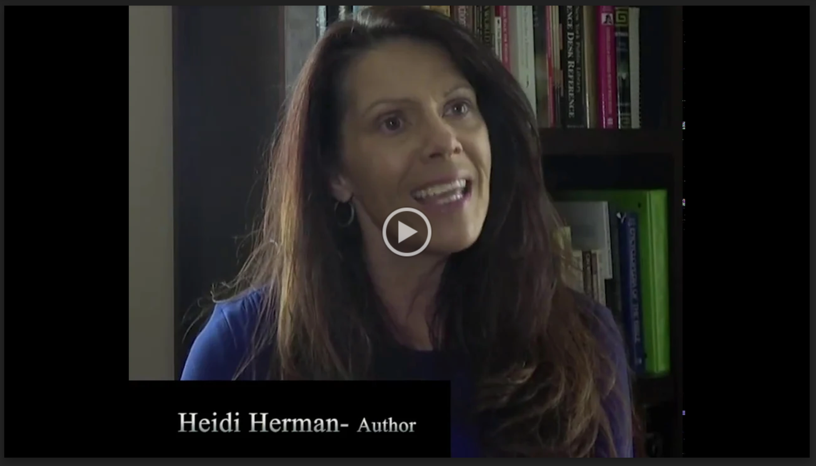
Heidi Herman Bio.mp4

Watch the Book Trailer:

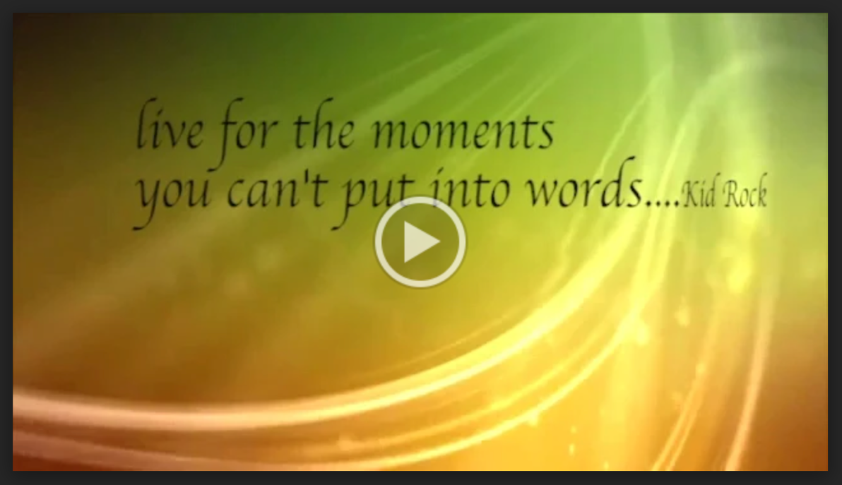
On with the butter...Book trailer.mp4
Book Specifications:

PUBLISHER: Hekla Publishing
PUBLICATION DATE: August 14, 2020
ISBN: 978-1-947233-03-4
SPECIFICATIONS: Paperback / Non-Fiction / Retirement & Aging
EXTENT: 241 pages
DISTRIBUTION: Ingram
PRICE: $16.99

Contact:

For more information or to request an interview with Heidi Herman, please contact Kelsey Butts at Book Publicity Services at Kelsey@BookPublicityServices.com or (805) 807-9027.

